Standard Operating Procedure for Laboratory Tube Furnaces

|  |  |
| --- | --- |
| Department: | Choose a department.  Enter department here if not listed. |
| Principal Investigator: | PI name. |
| Group Safety Coordinator/Lab Manager: | Name of safety contact. |
| SOP written by:  *All author’s names should be recorded in “Changes” section.* | Stephan Burdin  sburdin@illinois.edu |
| Date of this version of the SOP:  *Dates of revisions should be recorded in “Changes” section.* | Click here to enter the date of this version of the SOP. |
| Date SOP was approved by PI/lab supervisor: | Click here to enter date SOP was approved. |
| Lab Phone: | Enter the lab phone number |
| PI’s Phone: | Enter the PI office or mobile phone number |
| Location(s) covered by this SOP: | Enter the building and room number |
| Emergency contact information for this location: | Enter contact information of lab personnel to be notified in case of emergency. |

|  |  |  |  |
| --- | --- | --- | --- |
| Type of SOP: | Hazardous material  (SOP describes a specific hazardous chemical) | Hazardous class  (SOP describes a group of hazardous materials ) | Hazardous Process  (SOP describes a hazardous process or equipment) |

**NOTE**: This SOP is intended as an initial resource and as a general reference regarding the topic discussed. It is not a substitute for hands-on training and supervision by experienced laboratory personnel. The Principal Investigator must review and approve of all information in this document for the SOP to be valid and useable.

*This SOP is not complete until: 1) Clear and detailed instructions are written that will ensure safe handling of the material or safe performance of the procedure, and 2) SOP has been approved and dated by the PI or laboratory supervisor.*

Print a hardcopy and insert into your *Laboratory Safety Manual* and *Chemical Hygiene Plan*.

Table of Contents

Purpose 4

Key Points 4

Hazard Awareness 5

Definition of terms 5

Hazards and pertinent regulations 7

Means to control the hazards 8

Examples of hazardous materials or processes 10

Important considerations 11

Prior approval from PI required? 11

Consultation of other reference material, documents or knowledgeable persons required? 11

Pre-requisite training or skill? 11

Experiment Risk Assessment required? 11

Other important considerations: 11

Emergency response 12

Introduction to emergency response 12

Necessary emergency equipment 12

What to do if there is a spill or a fault in the process. 13

What to do if there is a spill or a fault in the process. 15

What to do if there is an exposure or injury 18

Storage 20

Considerations for safe storage of materials 20

Quantity limits and other considerations 20

Work Practices and Engineering Controls 21

Introduction to work practices and engineering controls 21

Designated area to work with the material or process 21

Necessary engineering or administrative controls. 21

If necessary, consult the 21

Required Personal Protective Equipment (PPE). 22

If necessary, consult the 22

Detailed procedures or techniques 23

Step-by-step procedures 23

Waste disposal procedure. 24

Record of changes made to this SOP 26

Training record 27

# Purpose

This SOP is designed to function as a starting point to illustrate the hazards associated with- and the best practices for operating laboratory-grade tube furnaces. It is not designed to furnish details for operation of a specific model of tube furnace or for the execution of a specific process/recipe. This SOP does not cover the use of high-pressure tube furnaces.

# Key Points

Groups must conduct a PPE assessment and ensure that furnace operators use appropriate PPE to protect themselves at all times:

• they must know the chemistry and reaction processes associated with the heating procedure to be performed and should conduct a risk analysis to ensure that risks are minimized, especially in case of a fault;

• they must understand the compatibility of materials used to contain specimen(s) and process gases at the proposed process temperatures;

• they must treat exhaust/reaction products from the heating procedure in an appropriate manner;

• they must know the limitations of their tube furnace and various components such as furnace tubes, sealed reaction vessels, and others;

• they must know how to safely handle/operate compressed gas supplies.

# Hazard Awareness

## Definition of terms

**Furnace:** Any electrically-powered heater used to heat materials to high temperature, generally in a controlled manner. In the context of laboratory use this commonly includes box furnaces, muffle furnaces, and tube furnaces. See figures 1-4 below.

**Tube Furnace:** A furnace having a cylinder as its specimen- and/or reaction-chamber. The cylinder, or tube, is often readily removable and can be sealed at both ends, allowing controlled-atmosphere reactions to be done. The furnace control system allows temperature ‘profiles’ or ‘recipes’ to be executed (temperatures and their durations, as well as their rates-of-change are fully controlled). Numerous sizes and varieties exist, including multi-zone tube furnaces that have different temperature regions along the length of the furnace tube.

Common uses for materials synthesis include annealing, oxidation, diffusion, doping, crystal growth, nanotube growth, etc. See figures 2-4 below.

**Tube** or **Furnace Tube:** In this context the furnace tube is the reaction chamber where specimens and/or specimen reaction ampules are placed and heated. It is literally a long cylinder, commonly made of Quartz or Alumina (Al2O3). It allows the exclusion of air from the reaction (at minimum), and allows a region of controlled atmosphere (humidity, noble- or reducing gas, etc.) to be maintained throughout a desired process, as well as a region of controlled temperature. It also physically separates the reaction volume from other furnace components such as the heater elements, enclosure, and control electronics.

**End Cap**: A device used to seal the ends of the furnace tube, allowing specimens to be heated in a controlled atmosphere and exhaust gas flow to be controlled/managed. End caps are commonly water-cooled because they are typically made of metal (brass, aluminum) and employ O-rings to accomplish a positive seal to the furnace tube. See figure 7.

**Boat:** A pan or flat surface used to keep a specimen inside the furnace tube from contacting the tube, and/or to keep it horizontal so that it doesn’t spill. Often this is used to minimize contamination of - or deposition of material onto - the surface of a furnace tube. Boat materials are chosen to minimize undesired reactions or contamination. See figure 8.

**Push rod:** A device used to move specimens to the desired position inside the furnace tube (often the center). A rod of sufficient length is necessary. Consideration should be given to materials to avoid contamination of the furnace tube when the push rod is inevitably dragged across its inside surface during specimen insertion/removal operations. For example, the use of a steel rod with an alumina furnace tube virtually ensures contamination of the tube with transition metal- and carbon contaminants. This is often undesirable. In this example the use of an alumina push rod is preferred.

Definition of terms, cont’d…

**High-Pressure Tube Furnace**

A tube furnace that has a reaction chamber designed to withstand heat and high pressure. These tubes can be filled with compressed gas to hundreds of psi (rather than being designed to flow gas through them at essentially ambient pressure or a few psi above).

The furnace tubes used in these applications are commonly made of a nickel-based superalloy. The alloy does not experience brittle fracture and explosion when it fails or is over-pressurized. Instead, its ductility and tensile properties cause it to swell and eventually crack, resulting in pressure relief (a leak) without explosion. *This SOP does not cover the use of these types of tube furnaces.*

Examples

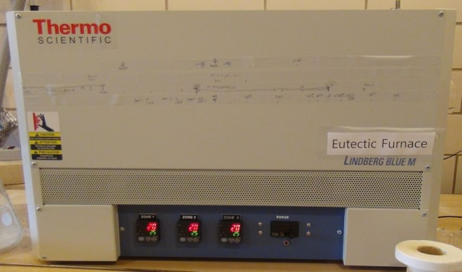  
Fig 2: 3-zone tube furnace.

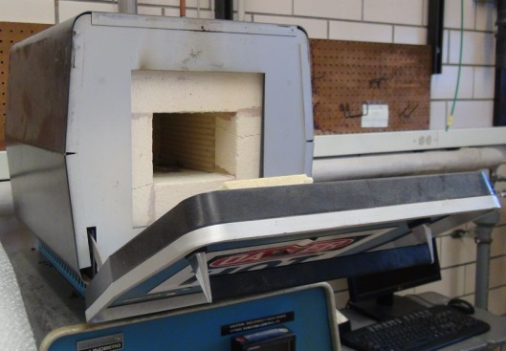  
Fig 1: Box- or Muffle-furnace.

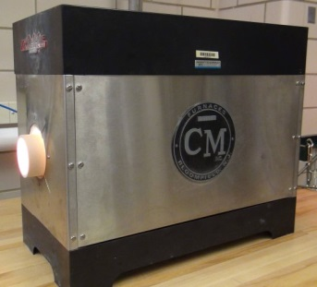  
 Fig 4: High Temperature tube furnace  
with an alumina furnace tube installed.

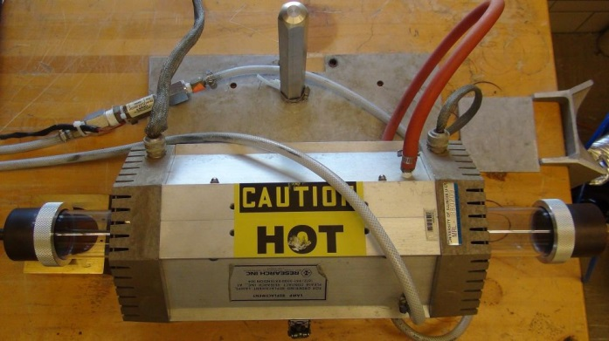Fig 3: Rapid Thermal Processing / Annealing (RTP / RTA) tube furnace with a quartz furnace tube installed.

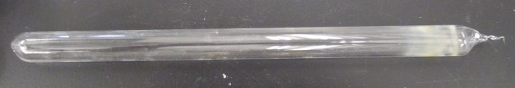

Fig 6: Sealed specimen ampule (approx. 4-inches long)

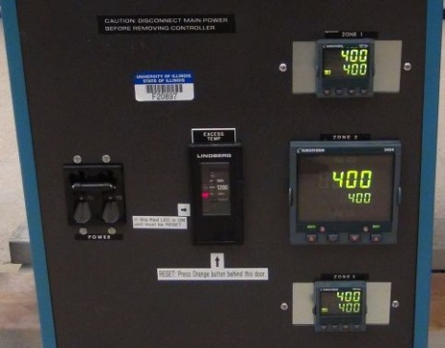  
 Fig 5: Controls for a 3-zone furnace  
note the three temp controllers (arrows)

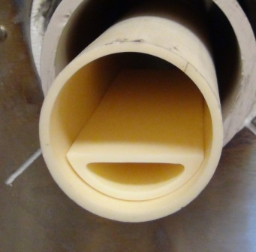  
Fig 8: Boat inside a furnace tube.

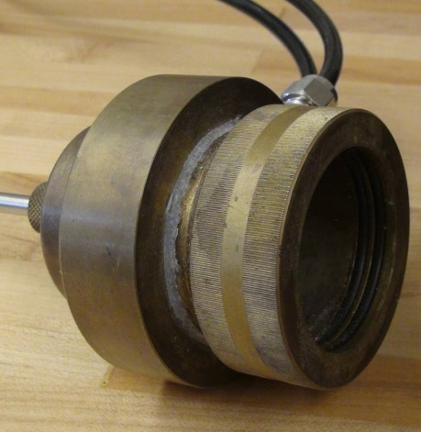  
Fig 7: Water-cooled end cap

## **Hazards and pertinent regulati**ons

Operations involving tube furnaces include work performed in numerous hazard categories. The risks are varied, and will depend on the process performed. Some are obvious and some are less so. Research groups should perform a comprehensive [**hazard assessment**](http://www.drs.illinois.edu/Programs/StandardOperatingProcedures/)* based on all elements of their proposed operation to determine their risk of exposure to the hazards proposed below, and to discover and understand others not mentioned here. The list below will offer some assistance. Possible hazards include:

**Burns:** Furnace tubes, furnace cabinets, handling tools, specimens, and carriers may be extremely hot. Radiation/glare from very hot objects can pose a hazard to the skin and eyes.

**Sharp edges:** Furnace tubes, be they quartz or alumina, exhaust tubing, gas supply lines, etc. may have very sharp edges.

**Gas cylinder operations:** Pressurized cylinders represent substantial hazards during handling and use.

**Exposure to gases:** Gases may be inert, asphyxiant, oxidizing, toxic, etc. It is possible to be exposed to process/purge gas if a leak occurs. Compatibility of plumbing (including the furnace tube) must be considered. Gas leaks can occur in gas line connections, furnace tube end caps, etc.

**Pressurization:** when heated, the pressure inside sealed specimen ampules may rise dramatically, potentially creating a severe risk of breach. Furnace tubes should not be pressurized.

**Vacuum:** Some furnace tube operations include evacuation to remove air and contaminants prior to desired purge and process steps. This means that an implosion risk exists, especially if there are flaws in the furnace tube or if it is struck by some object during the procedure.

**Fire:** Working gases may be flammable or may support combustion. Specimens may thermally decompose and catch fire or create smoke – especially if a leak occurs.

**Decomposition products/reaction products:** Reaction products could enter the room if a leak occurs. This can be caused by a failure of gas line connections, furnace tube end cap leaks, etc.

**Inhalation of dusts:** Tube furnaces are commonly insulated using refractory-metal-ceramic-fiber-based insulation materials. If these materials are disturbed they readily create fine dust, which are possible respiratory hazards. You should avoid generating and inhaling these particles.

**Electrical hazards:** Furnaces are electrically operated devices. Heater elements are exposed inside the enclosure. Good furnace design should make it very difficult to come in contact with electrical conductors during normal operation; however, it may be possible to come into contact with these items when working with a furnace during maintenance.

**Quenching:** (In this context, quenching is used to describe a heat-treating method where an object is rapidly cooled to obtain certain material properties.) The use of a tube furnace of the size and type typically encountered in a research laboratory to perform quenching is extremely risky. Tube furnaces with rather small diameter tubes (6-inches to 2-inches or less) are typically used in these environments, making specimen handling “at temperature” a very awkward endeavor - so much so that the tube furnace should not be considered an appropriate tool for this operation. It’s generally not possible to remove furnace-tube end caps during a process without a high risk of burning yourself and/or breaking the furnace tube.

**Specimen Ampules:** Sealing specimens in ampules is a specialized operation involving the use of (typically) quartz tubes, torches to heat and “pinch off” the quartz tube ends, and gas-filling “jigs” to fill them with a desired reaction gas (see Fig. 6). Numerous hazards are associated with handling ampules, heating them with torches, evacuating them, using compressed gases to fill them, and heating the resulting sealed volumes to high temperatures inside a tube furnace. *This SOP does not cover sealing of specimens in ampules.*

## Means to control the hazards

In response to a [**hazard assessment**](http://www.drs.illinois.edu/Programs/StandardOperatingProcedures/)*, groups can plan how to minimize the risks of working with tube furnaces - especially in combination with their process(es). This includes the use of PPE, the development of specific steps in the SOP, the use of engineering controls such as the layout of the laboratory space around the furnace, exhaust connections, etc. The goal is to reduce the likelihood of exposure and/or injury when something goes wrong. The minimum PPE for use of a tube furnace includes eye protection, protection from burns, and protection when handling furnace tubes (see: *required PPE*). Addressing the list in the previous section yields the following suggestions:  
**Burns:** Handle items only when cool, if possible. Otherwise use appropriate PPE (heat-resistant gloves). Always wear eye protection when working near furnace tubes, handling them, etc.!   
**Sharp edges:** Use leather gloves to protect against cuts when handling cool furnace tubes and exhaust tubing.   
**Gas cylinder operations:** Operators must be familiar with handling gas cylinders, installing and operating pressure regulators, flow devices, etc. They must appreciate the risks associated with use of a particular gas, including the potential exhaust products resulting from the desired process reaction. Training for gas cylinder operations and associated equipment (such as pressure regulators) is recommended.   
**Exposure to gases:** Operators must exhibit some level of competence in making secure (leak free) connections to gas tubing, furnace tubes, bubblers, exhaust lines, etc. Connections should be robust and well secured using quality, compatible materials and products to ensure their function even in the case of accidental contact or faults/mistakes during operations. In processes where more than one gas or gas-mixing is desired, appropriate check valves should be used to minimize consequences of operator error and to ensure intended gas flow direction.   
**Pressurization:** Calculations should be made to determine pressures that will be encountered when heating sealed specimen ampules, and the experiment designed to avoid breach or rupture of these vessels. A detailed set of instructions for filling and sealing ampules (an SOP) should be developed to assure safe, predictable behavior and results during these operations.   
**Vacuum:** The use of furnace tubes that can support atmospheric pressure without collapse is essential if evacuation is a desirable step in the process. Laboratory layout should be designed to minimize the risk of accidental contact with the evacuation system and furnace tube (ample space, etc.). Protective eyewear should ALWAYS be worn around an evacuated furnace tube.   
**Fire:** Connections should be leak free. The experimental design should take into consideration what reactions will occur during the process. This should include the possibility of air ingress (a leak). A plan of action should be developed to prepare operators for the possibility of a fire.   
**Decomposition products/reaction products:** Operators must exhibit some level of competence in making secure (leak free) connections to gas tubing, furnace tubes, bubblers, exhaust lines, etc. Connections should be robust and well secured using quality, compatible materials and products to ensure their function even in the case of accidental contact or faults/mistakes during operations.   
**Inhalation of dusts:** Furnace tube installation and removal and furnace maintenance (such as heater replacement) should be conducted with due care to avoid contacting furnace insulation.  
**Electrical hazards:** Electrical wiring should be in good condition and should be inspected regularly to ensure its safety. Cracked or frayed power wiring must be replaced. Furnace control electronics and consoles should be operated with covers in place. Contact with heater elements should be avoided.   
**Quenching:** The use of a laboratory tube furnace to perform quenching should be considered as use of the wrong tool for the task. See: ‘Quenching’ in *Discussion of Hazards*, above.  
**Specimen Ampules:** Sealing specimens in ampules (usually with a specific gas inside) is a specialized operation that warrants development of procedures to perform this safely and consistently. Among other particulars, gas pressures must be carefully controlled to ensure that the ampule survives the desired heating process in the tube furnace.  
  
* Hazard/risk assessment: [Risk Assessment for Chemical Experiments](http://www.drs.illinois.edu/site-documents/RiskAssessmentWorksheet.docx)

## Examples of hazardous materials or processes

Use this section to include examples that are more likely in your environment. A few examples include:

* Oxidizers in combination with high temperatures and organic materials
* Process-gas flow rates should be kept low enough to avoid displacing small particles / nanomaterials. Otherwise this could create an inhalation hazard.
* Be aware of auto-ignition temperatures for certain gases/materials such as Hydrogen, Methane, etc.
* Toxic gases must be treated with utmost care, stored in a gas cabinet, etc.

# Important considerations

## **Prior approval from PI required?**

Answer Yes or No. If Yes, consent must be obtained from the PI before performing the experiment or procedure.

## Consultation of other reference material, documents or knowledgeable persons required?

Examples include equipment operating manuals, **SDS documents for process gases and for specimen materials**, **SOPs for handling compressed gas supplies**, specifications and limitations of materials used such as tubes, boats, end caps; documentation for gas sealing technologies used when preparing gas lines; other background information. It is critical to identify the by-products evolved by the thermal processes, and the hazards they pose to the operator should the tube leak or the exhaust system fail.

## Pre-requisite training or skill?

Examples include basic compressed gas training, equipment training, etc.

## Experiment Risk Assessment required?

If necessary, consult this link: [Risk Assessment for Chemical Experiments](http://www.drs.illinois.edu/site-documents/RiskAssessmentWorksheet.docx)

Enter any required risk assessment step or procedure.

## Other important considerations:

Any special First Aid concerns? Any special tips or tricks?

# **Emergency response**

## Introduction to emergency response

A laboratory and/or process-specific plan of action should be developed to increase the likelihood of predictable assessment of- and behavior during- an emergency. This plan should become part of the training procedure.

A well-prepared emergency response will include a plan for emergency shutdown of the furnace and termination of a process. Operators should be trained on the plan. All training should be documented.

**Scenarios**

When imagining what could happen during a high temperature heating process, a host of scenarios come to mind. Many would almost naturally include:

**fire** (situation where it is contained within the furnace tube and one where it is not),

**smoke evolution** (contained and not contained),

**breach** of gas lines, furnace tubes, or specimen ampules (including explosion),

**release** of gas or reaction products,

**breakage** of furnace tubes, with or without further complication.

Research groups should consider other emergencies unique to their process and document them in this section. The SOP isn’t pertinent unless it contains information that is useful to the group.

## Necessary emergency equipment

Suggestions for emergency equipment will range from the obvious to those that become obvious only when a comprehensive approach is taken during the creation of a plan to deal with emergencies. That approach would take the entire process into account.

Emergency equipment must be present before work is begun. Operators should be familiar with locations of all emergency equipment.

* Fire alarm - identify where pull stations are.
* Fire extinguisher of the correct type.
* A chemical fume hood - if available - can be used to remove gas/fumes from the lab space in an emergency by opening the sashes fully and closing the laboratory door. The fume hood must be working properly.

## What to do if there is a spill or a fault in the process.

**Before work begins –** You must know how to clean up or react to a spill or leak of any material that you will be using before you begin your process! This is part of the hazard assessment process.

**Comfort level:** Only the person dealing with the emergency or the Principal Investigator should decide whether it is too large, complicated, or dangerous to handle safely. Do not hesitate to call for help in an emergency.

**Scenarios**

Research groups should consider other emergencies particular to their process and document responses to them in this section. Modifications deemed sensible to the responses below should be incorporated into the document. The SOP isn’t pertinent unless it contains information that is useful to the group.

**Fire**

In almost all imaginable cases, **a fire warrants immediate evacuation of the laboratory and activation of the building fire alarm!**

* If possible, turn off the power to the furnace when leaving the laboratory. Do not put yourself in danger to accomplish this.
* If possible, shut off the gas supply if it supports combustion. Do not put yourself in danger to accomplish this.
* Activate the building fire alarm and alert nearby personnel to evacuate.
* Call 911 from a safe location to alert emergency responders. Meet responders to inform them of the situation.

If the **fire is contained** within the furnace tube **and it is safe to do so**…

* Terminate the heating process using your emergency shutdown plan
* Shut off the gas supply if it supports combustion

Your next action depends upon whether the fire is extinguished or not:

* If **not**, you should consider this an escalation of the situation and **follow the instructions for a Fire** - above.
* If it does, allow the system to cool down, monitoring for an escalation of the situation.

**Note** that if the gas supply serves to extinguish the fire (such as Argon or another noble gas), it may be useful to leave it flowing.

**Smoke evolution**

Presuming that the smoke is contained within the furnace tube and exhausts away without entering the laboratory air, this scenario will require some assessment “on the spot” to deal with.

* Terminate the heating process using your emergency shutdown plan
* Shut off the gas supply if it supports creation of smoke
* If safe to do so, monitor for a fire and react accordingly if it occurs

If the smoke is not contained, follow the steps below in *Release of gas or reaction products.*

**Breach of gas lines, furnace tubes, or specimen ampules (including explosion)**

In this scenario it is unlikely that the operator is able to do anything in the laboratory. Hence

* Evacuate the laboratory, closing the door on your way out if possible.
* Activate the building fire alarm and alert nearby personnel to evacuate.
* Call 911 from a safe location to alert emergency responders. Meet responders to inform them of the situation.

In the case of a specimen ampule rupture that is **contained within the furnace tube** it may be possible to handle the situation. The key here is that you must be sure (somehow) that the furnace tube is **intact** and that therefore no reaction products have been released into the laboratory. Needless to say, this is a difficult determination to make “on the spot.”

In case of a simple gas line failure, it may be manageable. Consider how to safely proceed if a process was underway. If it is safe, close off the gas supply and repair the problem.

**Release of gas or reaction products**

Response to this scenario is greatly assisted if you understand the reaction products of your process in advance, as suggested previously. This scenario presumes a release into the laboratory. Unless you are completely assured that the release is inert or noble, or that it is safely manageable, you should:

* Evacuate the laboratory, closing the door on your way out if possible. If a fume hood is available, open the sashes to help remove gas from the laboratory. Do not put yourself in danger to accomplish this.
* Activate the building fire alarm and alert nearby personnel to evacuate.
* Call 911 from a safe location to alert emergency responders. Meet responders to inform them of the situation.

**All situations involving leaks of toxic or life-threatening materials should be considered exceptionally hazardous and should not be handled by you.** In these cases you should:

* Evacuate the laboratory, closing the door on your way out if possible.
* Activate the building fire alarm and alert nearby personnel to evacuate.
* Call 911 from a safe location to alert emergency responders. Meet responders to inform them of the situation.

**Breakage of furnace tubes**

If the breakage is due to an explosion, **you must treat this as a *release of gas or reaction products*** (see above), unless the furnace tube broke during an evacuation step AND no gas is involved.

Handling of broken alumina or quartz pieces presents obvious risks. You must know what contaminants may be on the furnace tube before attempting the following.

* Wear protective eyewear and a lab coat.
* Use leather gloves to protect yourself from cuts and potential poisoning.
* Use a dustpan and broom to carefully collect the broken pieces. Be mindful that this activity could create a dust hazard (from powder samples) and modify your tactics accordingly.
* Place collected debris into an appropriate container for disposal (plastic pail that can be sealed, cardboard box, etc.). The determination of the container depends upon the state of the furnace tube (what it’s contaminated with, if anything).
* Dispose of the debris according to its hazard class.

If the breakage occurs while the tube is installed in the furnace:

* Execute your emergency process-interruption steps if a process was running, including shutting off the gas supply.
* Ensure that the furnace and all parts have cooled.
* Ensure that the furnace is powered OFF.
* Determine what parts can remain inside the furnace without consequence (clean furnace-tube pieces that don’t affect the heater elements, furnace insulation, or that don’t evolve any contaminants when heated can be harmless).
* Clean up the pieces as described above, manually picking up pieces in or on the furnace - **use PPE!**

## What to do if there is a spill or a fault in the process.

**Before work begins –** You must know how to clean up or react to a spill or leak of any material that you will be using before you begin your process! This is part of the hazard assessment process.

**Comfort level:** If the person dealing with the emergency or the Principal Investigator decides that the spill is too large, too complicated, or too dangerous to handle safely, he/she should call for help. Do not hesitate to call for help in an emergency.

**Scenarios**

Research groups should consider other emergencies particular to their process and document responses to them in this section. Modifications deemed sensible to the responses below should be incorporated into the document. The SOP isn’t pertinent unless it contains information that is useful to the group.

**Fire**

In almost all imaginable cases, **a fire warrants immediate evacuation of the laboratory and activation of the building fire alarm!**

* If possible, turn off the power to the furnace when leaving the laboratory. Do not put yourself in danger to accomplish this.
* If possible, shut off the gas supply if it supports combustion. Do not put yourself in danger to accomplish this.
* Activate the building fire alarm and alert nearby personnel to evacuate.
* Call 911 from a safe location to alert emergency responders. Meet responders to inform them of the situation.

If the **fire is contained** within the furnace tube **and it is safe to do so**…

* Terminate the heating process using your emergency shutdown plan
* Shut off the gas supply if it supports combustion

Your next action depends upon whether the fire is extinguished or not:

* If **not**, you should consider this an escalation of the situation and **follow the instructions for a Fire** - above.
* If it does, allow the system to cool down, monitoring for an escalation of the situation.

**Note** that if the gas supply serves to extinguish the fire (such as argon or other inert gas), it may be useful to leave it flowing.

**Smoke evolution**

Presuming that the smoke is contained within the furnace tube and exhausts away without entering the laboratory air, this scenario will require some assessment “on the spot” to deal with.

* Terminate the heating process using your emergency shutdown plan
* Shut off the gas supply if it supports creation of smoke
* If safe to do so, monitor for a fire and react accordingly if it occurs

If the smoke is not contained, follow the steps below in *Release of gas or reaction products.*

**Breach of gas lines, furnace tubes, or specimen ampules (including explosion)**

In this scenario it is unlikely that the operator is able to do anything in the laboratory. Hence

* Evacuate the laboratory, closing the door on your way out if possible.
* Activate the building fire alarm and alert nearby personnel to evacuate.
* Call 911 from a safe location to alert emergency responders. Meet responders to inform them of the situation.

In the case of a specimen ampule rupture that is **contained within the furnace tube** it may be possible to handle the situation. The key here is that you must be sure (somehow) that the furnace tube is **intact** and that therefore no reaction products have been released into the laboratory. Needless to say, this is a difficult determination to make “on the spot.”

In case of a simple gas line failure, it may be manageable. Consider how to safely proceed if a process was underway. If it is safe, close off the gas supply and repair the problem.

**Release of gas or reaction products**

Response to this scenario is greatly assisted if you understand the reaction products of your process in advance, as suggested previously. This scenario presumes a release into the laboratory. Unless you are completely assured that the release is inert or non-hazardous, or that it is safely manageable, you should:

* Evacuate the laboratory, closing the door on your way out if possible. If a fume hood is available, open the sashes to help remove gas from the laboratory. Do not put yourself in danger to accomplish this.
* Activate the building fire alarm and alert nearby personnel to evacuate.
* Call 911 from a safe location to alert emergency responders. Meet responders to inform them of the situation.

**All situations involving leaks of toxic or life-threatening materials should be considered exceptionally hazardous and should not be handled by you.** In these cases, you should:

* Evacuate the laboratory, closing the door on your way out if possible.
* Activate the building fire alarm and alert nearby personnel to evacuate.
* Call 911 from a safe location to alert emergency responders. Meet responders to inform them of the situation.

**Breakage of furnace tubes**

If the breakage is due to an explosion, **you must treat this as a *release of gas or reaction products*** (see above), unless the furnace tube broke during an evacuation (vaccum) step AND no gas is involved.

Handling of broken alumina or quartz pieces presents obvious risks. You must know what contaminants may be on the furnace tube before attempting the following.

* Wear protective eyewear and a lab coat.
* Use leather gloves to protect yourself from cuts and potential poisoning.
* Use a dustpan and broom to carefully collect the broken pieces. Be mindful that this activity could create a dust hazard (from powder samples) and modify your tactics accordingly.
* Place collected debris into an appropriate container for disposal (plastic pail that can be sealed, cardboard box, etc.). The determination of the container depends upon the state of the furnace tube (what it’s contaminated with, if anything).
* Dispose of the debris according to its hazard class.

If the breakage occurs while the tube is installed in the furnace:

* Execute your emergency process-interruption steps if a process was running, including shutting off the gas supply.
* Ensure that the furnace and all parts have cooled.
* Ensure that the furnace is powered OFF.
* Determine what parts can remain inside the furnace without consequence (clean furnace-tube pieces that don’t affect the heater elements, furnace insulation, or that don’t evolve any contaminants when heated can be harmless).
* Clean up the pieces as described above, manually picking up pieces in or on the furnace - **use PPE!**

## What to do if there is an exposure or injury

**Before work begins –** You must know how to reach resources to call for help (a phone, the fire alarm, other laboratory personnel, etc.). You should know response protocol for all materials and gases that you’re working with.

**Exposure to Process Gas/Reaction Products/Exhaust**

Move to an area of fresh air. Know the symptoms of exposure, asphyxiation, etc. and respond accordingly. Keep in mind that your judgement may be impaired so don’t hesitate to get help from a lab mate. **Third party:** assist the victim to an area of fresh air. If it is during regular work hours, inform the PI or supervisor. Seek medical assistance*. In case of life-threatening situations (impaired or loss-of consciousness, difficulty breathing, etc.) **call 911 immediately!** Stay with the victim. If possible, ask another person to meet responders so that they can find you quickly.

**First Aid for Burns**

Get help from a lab mate. If no one is available to help you, **call 911 immediately.** Seek medical care without delay*.

**Third party:** Keep the victim calm and seek medical assistance for the victim*. If possible, ask another person to meet responders so that they can find you quickly.

**First Aid for Cuts** (primarily due to handling furnace tubes, etc.)

Clean and bandage the wound if possible. If it is during regular work hours, inform the PI or supervisor. Seek medical assistance*.

*See the Division of Research Safety guidance document [**Medical Treatment Options**](http://www.drs.illinois.edu/AccidentResponse/MedicalTreatmentOptions) for more information.

*PIs and Lab managers: enter first aid information for specific materials used in your lab.*

# Storage

## Considerations for safe storage of materials

Furnaces are often turned off when left in an idle state. Turn off the cooling water if not needed to prevent large spills in case of an unattended leak and to reduce water consumption. Some applications require the furnace to be left at an elevated temperature. Specific procedures should be determined by the individual research groups.

**Furnace Tubes**

It’s generally preferred to store these items where they won’t be damaged or contaminated. Furnace tubes that are contaminated from process operations should be stored according to hazard class and compatibility considerations.

**Gases**

* Gas cylinders should be stored/operated in an upright fashion, secured at midpoint or above with the appropriate bracket and tether mounted to a secure structure.
* They should be stored according to manufacturer’s SDS.
* They should be stored a safe distance from the point of use (heat sources, furnaces, etc.).
* They should be stored away from chemically incompatible materials.
* They should be stored away from electric circuits or electrically energized systems.
* Quantities should be kept to a minimum.

## Quantity limits and other considerations

Specify applicable regulatory or self-imposed storage quantity limits.

# Work Practices and Engineering Controls

## Introduction to work practices and engineering controls

Certain practices, when performed safely and consistently, ensure operational success and personal safety as well as quality results. Practices may include:

* Don’t store items on top of the furnace
* Inspect the furnace regularly (consult manufacturer’s guidelines)
* Keep flammable items away from the furnace (paper, solvents, etc.)
* Installation of gas tubing, exhaust piping, and connections should be robust and well secured using compatible, quality materials and parts.
* Before the heating process, verify operation of essential functions that are used to avoid damage (water cooling, for example).
* Verify that safety controls are in place and operating (interlocks, bubblers and liquid level, etc.).
* Employ smart system design and devices to allow some fault tolerance in case of user error or process fault.
* Operators may elect to use a purge gas step to ensure that it’s safe to open furnace tubes after the process has finished.
* Furnace tubes that are sufficiently contaminated should be replaced.
* Once a process has been started, it should be monitored until it reaches a steady state (for example to make sure that the reaction isn’t likely to “run away”). For long processes, operators should return regularly to check on the operation.
* Ensure that emergency equipment is in place and available before beginning your work.
* Use your PPE!

## Designated area to work with the material or process

The work areas should contain necessary equipment (or easy access to it), and sufficient controls to operate safely.

The furnace should be installed in a compatible space, with sufficient room around it to allow operation and to minimize the risk of accidental contact with plumbing, piping, furnace tubes, etc. Crowding the area around the furnace is unsafe.

The tube furnace should be installed on a sturdy, stable work surface.

Ensure that other experiments in the laboratory are not in the space occupied by the furnace and its operation. Keep flammable items and ignition sources away.

## **Necessary engineering or administrative controls.**

If necessary, consult the [Campus guidance on chemical fume hoods](https://www.drs.illinois.edu/SafetyLibrary/ChemicalFumeHoods).

* The laboratory where the furnace is operated should contain a LOG sheet or book to inform others when the furnace is in use and what the process traits are.
* Furnaces should be unambiguously labeled/named when more than one shares a lab.
* The laboratory should have a dedicated exhaust system to remove exhaust gases from the furnace tube.
* When toxic gases are used, appropriate gas handling equipment is essential, including gas cabinets, gas detection sensors, etc.
* When toxic gases are used, the furnace should be located and operated inside a working chemical fume hood in case of a breach or leak.
* When multi-part-gas, multi-step-gas or gas-mixing operations are desired, appropriate check valves installed in gas lines help ensure proper gas flow and help to reduce the likelihood that a user error escalates into a fault or emergency.
* It is often desirable to use a ‘bubbler’ in the exhaust-end of the gas stream to monitor gas flow and to ‘scrub’ the exhaust before it leaves via the exhaust line. It is essential that the operator understands the chemistry associated with the process to ensure that this is used when it’s necessary to scrub the exhaust gas, and to ensure that a compatible bubbler medium (fluid) is used.
* The use of a mass flow controller can ensure more reliable and repeatable process-gas flow settings, and reduce over-use of gas supply.
* A rotameter can be used as a visual indicator to monitor gas flow.
* Gas cylinders should not be placed too close to the furnace. Ideally it is desirable to have access to them if the gas supply must be terminated in an emergency.
* A water cooling interlock is desirable. It prevents the system from heating without necessary water cooling (end caps). It adds a simple layer of fault tolerance to the process, guarding against a missed operation on the part of the user.
* A device that adds a visual and/or audible indication of water flow can also be helpful.

## **Required Personal Protective Equipment (PPE).**

If necessary, consult the [Campus guidance on personal protective equipment](https://www.drs.illinois.edu/SafetyLibrary/PersonalProtectiveEquipment)

Fully enclosed shoes must be worn in the laboratory (no sandals, etc.). Long hair and loose clothing should be constrained and full length pants or skirts must also be worn along with basic PPE to include but not limited to:

* **Eye protection –** Safety glasses meeting American National Standards Institute (ANSI) standard Z87.1 are required.
* **Eye protection** can also protect you from the heat and glare of extremely hot objects. Tinted safety eyewear and full-face shields can protect you from these hazards.
* **Gloves –** Gloves are required at all times. Glove choice should balance the need for dexterity and heat resistance. Different gloves may be necessary during different parts of your procedure (heat-resistant, cut-resistant, etc.).

**Lab coat –** preferably a flame-retardant, non-synthetic coat.

# Detailed procedures or techniques

## Step-by-step procedures

The procedures for individual furnace operation/individual research groups will vary widely due to the variety of equipment combinations available to the researcher (various furnace types and sizes, various temperature controller types and configurations, etc.). This is beyond the scope of this document, so **editing this document to suit your laboratory is essential**. A common sequence of steps will often resemble the following (based on a single temp-zone tube furnace). The material below is simplified because it omits particulars such as details of programming a specific temperature control system and others. This material should be added to your SOP or incorporated into it by reference to instructions for the device.

**Step-by-step Procedures**

The step-by-step procedure below is divided into six blocks of tasks: **Prepare**, **Inspect**,   
**Set up**, **Run**, **Repeat**, and **Finish**.

**Prepare**

* Read SDSs for materials and gases to be used in the experiment/process. Know handling and response protocols for normal use and for emergencies. If replicating published work, be sure sufficient details are known to do so, and be sure that you’re familiar with the aspects - and that you can judge the sensibility of the proposed work.
* Understand handling and procedures for wastes generated during the experiment.
* Learn how to operate gas-handling controls (cylinder pressure regulators, mass-flow controller systems, etc.). It is essential that you are familiar with the operation of these controls before attempting work.
* Install appropriate gas supply plumbing for the experiment.
* Ensure that sufficient gas supply is available for the duration of your process.
* Read and understand how to operate the furnace **and know its limitations**.
* Understand how to program the temperature controller used on the furnace.
* **Know the limitations of the furnace tube that you intend to use** (such as upper temperature limit & temperature rate-of-change limits). Furnace tubes have limits to how fast you can heat them!
* Ensure that the various tools/objects that you need to handle your specimens are available and are of compatible materials.
* Wear appropriate PPE during the various steps of this procedure.

**Inspect**

* Inspect the furnace for obvious damage (enclosure, heater elements, insulation, etc.).
* Inspect your furnace tube for damage, unacceptable contamination, cracks, etc. Reject and replace furnace tubes of suspicious or compromised quality.
* Inspect gas lines for proper installation, obvious damage, leaks etc.
* Inspect water-cooling lines for damage, leaks, proper operation, including function of interlocks.
* Inspect exhaust-handling system for damage, leaks, proper function - **verify flow!**

**Set up**

* Log the operation so others can tell that the furnace is in use.
* Install furnace tube
* Install one end cap (the order of steps here depends upon the ‘perishability’ of your specimen - is it air sensitive? Some researchers would do other preparatory steps first, then finish with the specimen insertion and end cap installation. Modify your approach accordingly.)
* Insert your specimen(s)
* Install the second end cap
* Install exhaust line connections, including a bubbler if necessary or desired
* Install process gas connections if not already done
* Program the temperature controller (follow its instructions and stay within the limits of the furnace and the furnace tube).
* Purge the furnace tube if necessary

**Run**

* Ensure that the exhaust line is open to the laboratory exhaust system
* Begin process gas flow if not already done
* Ensure that necessary water flow is turned on
* Energize/turn ON the heater circuits
* Begin (RUN) the temperature program using the temperature controller
* Monitor the process to ensure that it’s operating as expected

**Repeat**

Temperature controllers commonly retain the programmed temperature profile, allowing repetition.

* Allow enough time for gases to be purged and the system to cool sufficiently, then:
* Turn off the process gas flow
* Exchange specimens by removing the supply-side end cap and replace it when done
* Repeat the operation using the necessary steps above in the **Run** block

## Waste disposal procedure.

If necessary, consult the [Campus waste disposal guide](https://www.drs.illinois.edu/site-documents/WasteDisposalGuide.pdf) and [chemical waste quick start guide](https://www.drs.illinois.edu/Waste/ChemicalWasteQuickStartGuide).

This procedure will generate specimens to be used/analyzed elsewhere however it is possible to be left with specimens and contaminated furnace tubes that must be disposed. These should be handled in the following manner.

* Handle/prepare all waste materials according to their hazard class.
* Place materials into an appropriately constructed container.
* Clearly label the container with appropriate UI#.
* Clearly and properly complete the CWM-TRK form.
* Arrange for pick up by contacting the DRS Chemical Waste Section using the established channels and methods.

# Record of changes made to this SOP

Describe the changes made to this document since its creation.

|  |  |  |
| --- | --- | --- |
| **Date of change** | **Changed by** | **Description of change** |
|  |  |  |
|  |  |  |
|  |  |  |
|  |  |  |
|  |  |  |
|  |  |  |
|  |  |  |
|  |  |  |
|  |  |  |
|  |  |  |
|  |  |  |
|  |  |  |

Standard Operating Procedure for

# Training record

|  |  |  |  |  |  |
| --- | --- | --- | --- | --- | --- |
| **Training Date** | **Name of Trainer** | **UIN of Trainer** | **Initials of Trainer** | **Name of Trainee** | **UIN of Trainee** |
|  |  |  |  |  |  |
|  |  |  |  |  |  |
|  |  |  |  |  |  |
|  |  |  |  |  |  |
|  |  |  |  |  |  |
|  |  |  |  |  |  |
|  |  |  |  |  |  |
|  |  |  |  |  |  |
|  |  |  |  |  |  |
|  |  |  |  |  |  |
|  |  |  |  |  |  |
|  |  |  |  |  |  |
|  |  |  |  |  |  |
|  |  |  |  |  |  |
|  |  |  |  |  |  |
|  |  |  |  |  |  |
|  |  |  |  |  |  |
|  |  |  |  |  |  |
|  |  |  |  |  |  |
|  |  |  |  |  |  |