Standard Operating Procedure for Toxic Gases

Department: | Choose a department.  Enter department here if not listed.
Principal Investigator: | PI name.
Group Safety Coordinator/Lab Manager: | Name of safety contact.
SOP written by: | College of Engineering SOP Committee  engrsafety@illinois.edu
Date SOP was approved by PI/lab supervisor: | Click here to enter date SOP was approved.
Lab Phone: | Enter the lab phone number
PI’s Phone: | Enter the PI office or mobile phone number
Location(s) covered by this SOP: | Enter the building and room number
Emergency contact information for this location: | Enter contact information of lab personnel to be notified in case of emergency.

Type of SOP: (check one) | ☐Hazardous material  (SOP describes a specific hazardous chemical) | ☒Hazardous class  (SOP describes a group of hazardous materials ) | ☐Hazardous Process  (SOP describes a hazardous process or equipment)

NOTE: This SOP is intended as an initial resource and as a general reference regarding the topic discussed. It is not a substitute for hands-on training and supervision by experienced laboratory personnel. The Principal Investigator must review and approve of all information in this document for the SOP to be valid and useable.
This SOP is not complete until: 1) Clear and detailed instructions are written that will ensure safe handling of the material or safe performance of the procedure, and 2) SOP has been approved and dated by the PI or laboratory supervisor.
Print a hardcopy and insert into your Laboratory Safety Manual and Chemical Hygiene Plan.

Table of Contents
Purpose 4
Key Points 4
Important considerations 6
Prior approval from PI required? Answer Yes or No 6
Consultation of other reference material, documents or knowledgeable persons 6
Pre-requisite training or skill 6
Hazard Awareness 7
Introduction 7
Hazards and pertinent regulations 7
Experimental Risk Assessment 8
Means to control the hazards 8
Examples of hazardous materials or processes 10
Safe Work Practices: Engineering Controls, Administrative Controls, and PPE 11
Introduction to engineering controls, administrative controls, and PPE 11
Recommended work practices 12
Designated area to work with the material or process 12
Necessary engineering or administrative controls 12
Required Personal Protective Equipment. 13
Detailed procedures or techniques 14
Introduction 14
Step-by-step procedures 14
Waste disposal procedure. 16
Emergency response 17
Introduction to emergency response 17
Scenarios 17
Necessary emergency equipment 18
What to do if there is a material release or a fault in the process. 18
What to do if there is an exposure or injury 20
Storage 22
Introduction to proper storage of hazardous materials 22
Special storage requirements 22
Quantity limits and other storage considerations 22
Reference 23
Definition of terms 23
Tools and resources 28
Record of changes made to this SOP 30
Training record 31

Purpose
This SOP is designed to assist groups in establishing a procedure for their daily (or regular) operations with an experimental apparatus that requires the use of toxic gases.
This SOP does not cover system design, testing, and preparation for use in a new setup or laboratory. Please consult with the College of Engineering Office of Safety to begin this process.
NOTE: These guidelines are intended to function as an initial resource and as a general reference for research involving the use of toxic gases. They are not a replacement for personal hands-on training and supervision by experienced laboratory personnel, nor are they a replacement for ascertaining specific details concerning the safe execution of your process. Research groups should make lab-specific changes to this SOP by editing this document. The edited document should then be placed in the research group’s laboratory safety manual. All laboratory personnel who will be authorized users of the toxic gas lab must be trained. This training must be documented. Principal Investigators must approve of modifications before they are accepted into this document. Approval often requires departmental involvement and review by safety entities on campus if modifications are more extensive.

Key Points
- Groups must conduct a PPE assessment and ensure that operators use appropriate PPE to protect themselves at all times. PPE requirements may change during different phases of work. See Required PPE.
- Groups must conduct hazard and risk assessments and should strongly consider performing a security vulnerability assessment. This will equip them with the information they need to operate safely, protect themselves and their surrounding lab occupants, and to draft a relevant, comprehensive operating plan that helps accomplish these goals. See Discussion of Hazards.
- Researchers handling toxic chemicals should be thoroughly versed in the guidelines for safe handling of chemicals in laboratories and should have acquired (through a combination of training and experience) the knowledge and skill to consistently execute safe laboratory practice and have a track record of doing so;
  - they must know the chemistry and reaction processes associated with the experimental procedure to be performed and shall conduct a risk assessment to ensure that risks are minimized, especially in case of a fault;
  - they must treat exhaust/reaction products in an appropriate manner;
  - they must develop a detailed procedure for acquisition and disposal of gas supplies in coordination with their department.
- The designated area for this work should be recognized by everyone in the laboratory or building/institution as a location where special training, precautions, laboratory skill, and safety discipline are required.
- Unauthorized/untrained personnel shall not be allowed to operate in the same area.
- Many toxic gases fall into numerous hazard classes; including flammable, compressed gas, and pyrophoric.
- Operations involving toxic gas handling REQUIRE more than one person to be present.

Important considerations

Prior approval from PI required? Answer Yes or No
If the answer above is Yes, consent must be obtained from the PI before performing the experiment or procedure. Describe the approval process here.

Consultation of other reference material, documents or knowledgeable persons
Is this document sufficient or are other reference materials required? Examples include equipment operating manuals, SDS documents for process gases and for specimen materials, SOPs for handling compressed gas supplies, documentation for gas-sealing technologies, checklists to ensure that daily start-up or termination of work is completed without missing details, other background information.

Pre-requisite training or skill
Is any prerequisite training necessary before work is to begin? Examples include basic compressed gas training, toxic gas handling, equipment training, DRS laboratory safety training, respirator training and qualification, etc.

Hazard Awareness

Introduction
A hazard is a condition or circumstance that presents a potential for injury, illness or property damage. Hazards vary in nature and can be chemical, biological, physical (includes electrical, radiation, temperature extremes, pressure or vacuum, noise, mechanical), and ergonomic. The negative outcomes associated with hazards include exposure, poisoning, illness, shocks, burns, fires, slips and falls, spills, explosions, and perhaps even fatalities. It is important that you become aware of hazards inherent in the procedures undertaken or materials used in experiments. A comprehensive hazard identification and risk assessment should have been performed on this lab experiment to identify hazards and determine their risk of consequence from the hazards. Only by identifying hazards can solutions and strategies be developed to address the hazards and control them or minimize the risk (likelihood of adverse events or negative outcomes associated with the hazards). In addition, there are laws that apply to many workplace settings, including academic research laboratories, that require the assurance of a safe workplace, as well as regulations that set and enforce standards that need to be complied with to ensure a safe and healthful workplace.
For the SOP author: Perform a comprehensive hazard identification and risk assessment (see section on Tools and resources) on the chemical or process to identify hazards and determine their risks. You may keep the documentation of the hazard identification/risk assessment separate from the SOP, but list and discuss the hazards and risks below. It is important that researchers are made aware of hazards inherent in the procedures to be undertaken or materials to be used in experiments. The means to control the hazards should be made known to the researcher, so that he or she can apply them. Applicable laws or regulations should be cited and the means to comply with them should be stated.

Hazards and pertinent regulations
Operations involving the use of toxic gases will include work performed in numerous hazard categories. The risks are varied, and will depend on the process performed and on gases used. Research groups should perform a comprehensive hazard assessment* based on all elements of their proposed operation to determine their risk of exposure to the hazards proposed below, and to discover and understand others not mentioned here. The list below will offer some assistance. Possible hazards include:
Gas Leaks: The primary means of exposure is likely to be from leaks in the gas delivery system, or during gas cylinder exchange operations.
Gas cylinder operations: Pressurized cylinders represent substantial hazards during handling and use. Handling toxic gas cylinders adds to the number and types of hazards.
Exposure to gases: This presents a potentially serious threat to health and/or life because it is possible to be exposed to process gas if a leak occurs. Gas leaks can occur in gas line connections, when working with the laboratory apparatus, etc.
Fire: Toxic gases may also be flammable and/or pyrophoric. This could create a situation that quickly escalates into a more complex and dangerous situation if a leak occurs. Gas connections must be leak free.
Decomposition products/reaction products: Reaction products could enter the room if a leak occurs in the scrubbing system, for example.
Failure of warning systems: If the monitoring/detection system isn’t working, a vital component protecting and warning you is unavailable.
Gas cylinder transport: This operation is often considered routine but must not be treated this way when moving toxic gas cylinders. Failure of a gas cylinder due to damage during transport is likely catastrophic considering the uncontrolled environment (no containment, potentially a public space) that the cylinder is likely to be in during this operation.
Personnel behavior: Personnel without demonstrated discipline to follow procedures completely, without fail and those without training and experience/practice pose a higher risk when working with toxic gases.
Security Vulnerability: The security of some laboratory materials is regulated by government agencies. The Department of Homeland Security maintains a list of Chemicals of Interest (COI) which includes highly toxic gases. Risks including theft, sabotage to cause injury, unauthorized experimentation, etc. must be considered.
* For hazard/risk assessment tools, refer to the Reference section, under Tools for Performing a Lab Risk Assessment.

Experimental Risk Assessment
Summarize the results of the risk assessment procedure. Consult the Reference section for help with Risk Assessments.

Means to control the hazards
In response to a hazard assessment*, groups must plan how to minimize the risks of working with toxic gases - especially in combination with their processes. This includes the development of specific steps in the SOP, the use of engineering controls such as the layout of the laboratory space around the apparatus, exhaust connections, etc. The goal is to reduce the likelihood of exposure and/or injury during normal operations and when something goes wrong. Clearly a minimum set of procedures that reduces uncertainty in operational details and ensures the proper operation of devices that are designed to protect and warn you are desirable. Addressing the list in the previous section yields the following suggestions.
* For hazard/risk assessment tools, refer to the Reference section, under Tools for Performing a Lab Risk Assessment.
Gas Leaks: The controls designed to protect laboratory occupants and others in the building must be operational at all times. Steps must be documented and executed regularly to ensure that these systems are available to warn you of a leak. This means proper maintenance of consumable gas detection system components, proper maintenance of scrubbers, timely maintenance of power back-up systems, etc. Gas cylinder operations: Operators must be familiar with handling gas cylinders, installing and operating pressure regulators, flow devices, etc. They must appreciate the risks associated with use of a particular gas, including the potential exhaust products resulting from the desired process reaction. Training for gas cylinder operations and associated equipment (such as pressure regulators) is recommended. Experience in their use and a good track record should be a prerequisite before working with toxic gas cylinders.
Exposure to gases: Operators must exhibit a great deal of competence in making secure (leak free) connections to gas tubing, regulators, exhaust lines, etc. Connections should be robust and well secured using quality, compatible materials and products to ensure their function even in the case of accidental contact or faults/mistakes during operations. The gas delivery system must be leak tested when installed AND when any work is done on the system or changes are made. Operators should be thoroughly versed and practiced in the response to an exposure so that they are likely to act quickly and correctly in order to minimize the dose received during an exposure and in order to maximize their chances of surviving an exposure, should one occur. Fire: Many toxic gases are also flammable and/or pyrophoric. Lab occupants should be thoroughly versed in their preparation for what to do in case of a fire.
Decomposition products/reaction products: Reaction products and/or residual amounts of the process gas(es) must be scrubbed before release. The design of the laboratory space should have determined these byproducts and installed the appropriate handling systems to treat them. Changes to the process warrant a reevaluation of these handling systems before attempting the new process.
Failure of warning systems: Lab operators must ensure the operation of warning systems before beginning work on a daily basis. These systems typically also require periodic testing to assure that they’re still capable of detecting minute concentrations of the gas(es) being monitored. Consumable components must be replaced in a timely fashion to ensure operation.
Gas cylinder transport: This critical operation requires following a strict, documented procedure to ensure the safety of building occupants. Personnel behavior: Personnel must have a track record of reliability and discipline to ensure that steps aren’t skipped when performing the numerous operations described here. The many details involved means that regular review of the procedures further reduces this risk. Reviews should be required at least annually. The presence of unauthorized users during toxic gas operations should be prohibited. Security Vulnerability: Access control to the laboratory and control systems, as well as to some equipment can help reduce risks mentioned. A vulnerability assessment will reveal risks and allow researchers to minimize them. Locking the laboratory, having a clear, posted list of authorized users and allowed processes and strictly enforcing them, locking access to monitoring systems and process controls, and controlling access to equipment such as SCBAs will help protect against some of these risks. See: Prudent Practices in the Laboratory: Handling and Management of Chemical Hazards: Chapter 10.F - Security Vulnerability Assessment.

Examples of hazardous materials or processes
Use this section to include examples that are more likely in your environment. Table 1 is a list of representative toxic gases. A few general examples include:
- use of Silane, Disilane gas for growth of silicon-based films/structures (for example in CVD, PECVD, etc.)
- use of Arsine, Diborane, Phosphine, etc. as dopants in semiconductor growth processes (gas-source MBE, for example)
- Toxic gases that are by-products of reactions. For example, addition of acids to sulfide compounds produces hydrogen sulfide (see Table 2).
- Maintenance activity that requires access to the growth chamber or breach of gas lines requires a strict protocol to minimize the risk to those performing this work.

Table 1: Representative toxic gases.
Ammonia | Fluorine | Phosphine
Arsine | Germane | Phosgene
Boron trichloride | Hydrogen bromide | Silane
Boron trifluoride | Hydrogen chloride | Silicon tetrachloride
Carbon monoxide | Hydrogen fluoride | Silicon tetrafluoride
Chlorine | Hydrogen sulfide | Silicon tetrabromide
Diborane | Nitric oxide | Sulfur dioxide
Dichlorosilane | Nitrogen dioxide | Vinyl chloride

Table 2: Reactions between two compounds causing toxic gas release (Source: UCI Toxic Gas Program)
Compound 1 | Compound 2 | Toxic gas produced
Arsenic compounds | Any reducing agent | Arsine
Azides | Acidic compounds | Hydrogen azide
Cyanides | Acidic compounds | Hydrogen cyanide
Hypochlorites | Acidic compounds | Chlorine or Hypochlorous acid
Nitrates | Sulfuric acid | Nitrogen dioxide
Nitric acid | Copper, brass, any heavy metals | Nitrogen dioxide (nitrous fumes)
Nitric acid | Ethanol | Nitrogen dioxide (nitrous fumes)
Nitrites | Acidic compounds | Nitrous fumes
Phosphorus | Caustic alkalis or reducing agents | Phosphine
Selenides | Reducing agents | Hydrogen selenide
Sulfides | Acidic compounds | Hydrogen sulfide
Tellurides | Reducing agents | Hydrogen telluride

Safe Work Practices: Engineering Controls, Administrative Controls, and PPE

Introduction to engineering controls, administrative controls, and PPE
Safe work practices describe known safe and prudent policies and practices to adhere to in performing the experiment or procedure or in handling the materials. Some chemicals are acutely toxic or carcinogenic and require a designated area for work with these chemicals. A designated area may be the entire laboratory, an area of the lab, or a containment device such as a fume hood. Safe work practices may require the use of engineering controls, administrative controls and personal protective equipment (PPE). Engineering controls are methods that are part of the equipment or process to reduce or eliminate the hazard to the researcher. Administrative controls are changes to work procedures with the goal of reducing the duration, frequency and severity of exposure to hazardous materials or situations. Personal protective equipment or PPE refers to protective clothing, attire or garments designed to protect the wearer’s body from injury or exposure. In general, if the hazard cannot be eliminated or substituted out, engineering controls are favored over administrative controls and PPE, because well-designed engineering controls can be highly effective while not requiring effort on the part of the researcher to follow certain work policies or remembering to wear the correct protective equipment.
Certain practices, when performed safely and consistently ensure operational success and personal safety as well as quality results. These might include
- Laboratory personnel shall NOT work alone.
- Inspect the operation of the various safety systems regularly to ensure their operation
- Perform maintenance on systems without fail to ensure their operation
- Installation of gas tubing, exhaust piping, and connections should be robust and well secured using compatible, quality materials and parts.
- Employ smart system design and devices to allow some fault-tolerance in case of user error or process fault.
- Operators may be required to use a purge step after the process has finished in order to remove toxic gas from the delivery lines.
- Once a process has been started, it may be necessary to monitor it closely until it reaches a steady state. For long processes, operators should return regularly to check on the operation.
- Ensure that emergency equipment is in place and available before beginning your work.
- Use the required PPE for the process.
- Only qualified, experienced personnel who are specifically approved to work with the apparatus and specific process should perform this work. Access control measures should prevent others from being in the lab or attempting to operate the apparatus.
- It’s prudent to store the minimum practical gas cylinder size and to use the minimum dose required to achieve the desired reaction/result during the experimental procedure.
- In addition to normal operations, the system LOG book should document all maintenance operations, error or warning conditions from monitoring systems, etc.

Recommended work practices
Describe any work practices or policies in this section.

Designated area to work with the material or process
The work areas should contain necessary equipment (or easy access to it), and sufficient controls to operate safely.
The apparatus should be installed in a compatible space that has been prepared for use with toxic gases, with sufficient room around it to allow operation and to minimize the risk of accidental contact with plumbing, piping, etc. Crowding is unsafe.
Ensure that other experiments in the laboratory are not in the space occupied by the apparatus and its operation. Keep flammable items and ignition sources away.
The SOP should include a statement that describes the designated work area: a location where the SOP is valid such as the building, laboratory room number, and apparatus on which the work will be performed.

Necessary engineering or administrative controls
The laboratory should contain a LOG book to inform others about which process is underway and what the process traits are. It’s also helpful to know what the last operation was and what state the apparatus and gas handling system was left in.
- The laboratory should be unambiguously labeled/named to indicate that toxic gases are used.
- When toxic gases are used, appropriate gas handling equipment is essential, including gas cabinets, gas detection sensors, scrubbers, interlocks, automatic shut-offs, etc.
- When multi-part-gas, multi-step-gas or gas-mixing operations are desired, appropriate check valves installed in gas lines help ensure proper gas flow and help to reduce the likelihood that a user error escalates into a fault or emergency.
- For some operations a portable (hand-held) gas monitor may be needed and/or a personal gas monitor (akin to a wearable dosimeter) may be required.

Required Personal Protective Equipment.
Gloves and eye protection (for example) won’t protect you from exposure to gas. The use of PPE will be determined by the larger process that’s being done in the laboratory.
Fully enclosed shoes must be worn in the laboratory (no sandals, etc.). Long hair and loose clothing should be constrained and full length pants or skirts should also be worn along with basic PPE that includes but may not be limited to:
- Eye protection – Safety glasses meeting American National Standards Institute (ANSI) standard Z87.1 are required.
- Gloves – Glove choice should balance the need for dexterity and protection. Different gloves may be necessary during different parts of your procedure (heat-resistant, cut-resistant, etc.).
- Lab coat - use a flame-retardant, non-synthetic lab coat.
- SCBAs will be necessary for gas cylinder exchange operations, certain maintenance operations, etc. SCBAs should be located in a storage cabinet that allows them to be protected and locked, but that allows relatively easy access for the authorized users. All of the determinations about type, size, and necessity will be made by going through the campus respiratory protection program.
See the Division of Research Safety guidance document Personal Protective Equipment for more information. (www.drs.illinois.edu/SafetyLibrary/PersonalProtectiveEquipment)

Detailed procedures or techniques

Introduction
The procedures for running a process using toxic gas(es) will require following a very specific, detailed set of steps that ensure that the processes are performed safely and consistently. That level of detail is beyond the scope of this document, so use the knowledge you gained during your assessment and preparatory efforts to make a comprehensive set of procedures. A common sequence of steps might resemble the following general steps.

Step-by-step procedures
The step-by-step procedure below is divided into five blocks of tasks: Prepare, Inspect, Set up, Run, and Finish.
Prepare
- Read SDSs for materials and gases to be used in the experiment/process. Know handling and response protocols for normal use and for emergencies. If replicating published work, be sure sufficient details are known to do so, and be sure that you’re familiar with the aspects - and that you can judge the sensibility - of the proposed work.
- Understand handling and procedures for wastes generated during the experiment.
- Learn how to operate gas handling controls (cylinder pressure regulators, mass-flow controller systems, etc.). It is essential that you are familiar with the operation of these controls before attempting work.
- Know how to operate (and interpret messages from) the safety systems in the laboratory
- Ensure that sufficient gas supply is available for the duration of your process.
- Understand how to operate the apparatus.
- Know the limitations of the apparatus and gas delivery system such as gas delivery rates, pressure limits in the reaction chamber, scrubber capacity, etc.
- Ensure that the various tools/objects that you need to handle your specimens are available and are made of compatible materials.
- Wear appropriate PPE during the various steps of this procedure.
- Coordinate with your authorized lab buddy so that (s)he is present during your work.

Inspect
- Inspect the remote display for the gas detection system to ensure that readings are in the normal range (no detection) and that it’s safe to enter the laboratory.
- Inspect the gas detection system to ensure that it’s operating, to ensure that sensor modules haven’t expired, that sniffer lines aren’t clogged or damaged, etc.
- Inspect the portable and/or personal gas monitor for service requirement if you’ll be using it during the procedure that you’re preparing to do.
- Inspect gas cabinets to ensure that venting blowers are operational. It’s expected that safety system interlocks trigger an alarm if the extraction blowers are not functioning. This quick check helps ensure that this interlock is working.
- Inspect the function of the various system interlocks where possible.
- Inspect the laboratory apparatus for obvious damage.
- Inspect gas lines for damage, unacceptable modification, etc. Don’t run a process if items exhibit suspicious or compromised quality.
- Inspect the scrubber to make sure it’s working and isn’t due or overdue for service.
- Verify that gas delivery pressure settings are correct before opening other valves to the apparatus.

Set up
- Make an entry in the system LOG so others can tell that the system is in use and which process is underway. Log the gas pressure levels and other day-to-day operational data.
- Follow your procedure for specimen introduction into the reaction chamber.
- Perform any other preparatory steps before running the process.

Run
- Follow the documented steps to perform your process.
- Monitor the process to ensure that it’s operating as expected.

Finish
The steps used here depend upon how you leave the apparatus for the next use.
- Execute your finish/shutdown steps. Shut off the process gas when your process dictates that it’s no longer necessary.
- If your procedures dictate that you remove the process gas from the gas lines, do so following the checklist detailing that procedure.
- Log the system status, including gas pressure levels (to track consumption) and other day-to-day operational data.

Waste disposal procedure.
Several types of items may require disposal from this work, including specimen materials and gas cylinders.
This procedure will generate specimens presumably to be used/analyzed elsewhere however it is possible to be left with specimens that must be disposed. These should be handled in the following manner.
- Handle/prepare all waste materials according to their hazard class.
- Place materials into an appropriately constructed container.
- Clearly label the container with appropriate UI#.
- Clearly and properly complete the CWM-TRK form.
- Arrange for pick up by contacting DRS Chemical Waste Management using the established channels and methods. (Chem. Waste Quick Start Guide)
Disposal of gas cylinders is done according to a specific procedure that’s been developed for your lab and building/department. Document that process here.

Emergency response

Introduction to emergency response
While prevention of lab accidents is preferred, preparation for emergency situations is an essential part of good lab practice. A laboratory and/or process-specific plan of action should be developed to increase the likelihood of predictable assessment of- and behavior during- an emergency. This plan should become part of the training procedure.
Most emergency situations will necessitate evacuation and activation of the fire alarm.
A well-prepared emergency response will include a plan for emergency behavior, including evacuation and possible termination of a process. Operators should be trained on the plan. All training should be documented, practiced, and periodically repeated.

Scenarios
When imagining what could happen during a process that uses toxic gases, one imagines those that are contained inside the apparatus and those that are not. Those that are not contained to the laboratory apparatus likely start with a leak or intentional opening of a gas connection - presumably under mistaken pretense that no gas was present in the volume that was opened. They may also include a catastrophic failure that is hopefully contained within the containment system (gas cabinet). Scenarios that arise from this set of thought exercises include:
Accidental high-dose of gas inside the laboratory apparatus. This includes a malfunction of pressure regulation or leak valve operation, or a mistake by the operator when adjusting a dosing valve during a process step.
Leak (to the ambient) in the low pressure portion of the gas delivery system. The gas detection system should detect this eventually and issue a detection event/alarm. In some cases, the threshold of sensory perception is very low which means that personnel may sense the presence of the gas first. This is known to happen with Fluorine, for example. In this case occupant(s) should not doubt their senses; they should react as though a leak has occurred.
Leak in the high pressure portion of the gas delivery system. This should be contained within the gas cabinet and not reach the laboratory or public spaces surrounding it (hallways, etc.). Nonetheless, the gas detection system should detect this leak within the gas cabinet.
Breach of gas line(s). This could be a result of accidental contact with (bumping in to) a gas delivery line. This type of contact may cause a leak or an outright failure (break) of the gas line, and could also result in a fire. The laboratory apparatus and space should be designed to make a breach like this exceedingly unlikely to occur. Gas delivery lines should never be routed in any walkways, work-flow paths, or egress routes in the laboratory.
Fire. Many toxic gases are flammable and/or pyrophoric so an ignition source or exposure to air can cause a leak to turn into a fire, greatly complicating an already dire situation.

Research groups should consider other emergencies unique to their processes and document them in this section. The SOP isn’t pertinent unless it contains information that is specific to the group.
For the SOP author: Possible emergency scenarios should be anticipated, and preparations should be made to deal with these circumstances. Procedures describing what to do should be written below, as well as the necessary safety and emergency equipment needed to deal with emergencies.

Necessary emergency equipment
Suggestions for emergency equipment will range from ones that come to mind immediately to those that are revealed only when a comprehensive approach is taken during the creation of a plan to deal with emergencies. That approach would take the entire process into account.
Emergency equipment must be present before work is begun. Operators should be familiar with locations of all emergency equipment.
- Fire alarm - identify where pull stations are.
- Fire extinguisher of the correct type. The College of Engineering Office of Safety can offer guidance to help assure that the lab is equipped with the correct fire extinguisher. Remember, it is unlikely that occupants will be using a fire extinguisher to fight a fire unless it blocks their escape from the space.
- Emergency stop/gas shut off valve, preferably located near the laboratory’s egress route (the doorway).

What to do if there is a material release or a fault in the process.
Before work begins – You must know how to react to the scenarios above before you begin your process! This is part of the hazard assessment phase of preparation. Ensuring proper behavior to a sudden, emergency situation - especially a truly life-threatening one - is achieved only through practice and repetition. Read and go through the motions of response procedures regularly (drills).
Comfort level: In the case of a toxic gas leak, it is almost certain that the course of action will be to evacuate and activate the building’s fire alarm to cause others to evacuate. Return to the laboratory is likely only after an investigation that should lead to clearance and allow safe resumption of activity in and near the laboratory. Never hesitate to call for help in an emergency.

Lab-specific Scenarios
Research groups should consider other emergencies particular to their processes and document responses to them in this section. Modifications deemed sensible to the responses below should be incorporated into the document. The SOP isn’t pertinent unless it contains information that is useful to the group.
Accidental high-dose of gas inside the laboratory apparatus. The system must be able to handle the dose of gas. Presuming that this is true and the gas is contained to the laboratory apparatus, this may not be an emergency. Unreacted product must be scrubbed before release to the environment, so the scrubbing system must be able to handle the dose. This determination must be made on the spot. Calculations during the preparatory phase to determine what the system can handle (knowledge of your scrubber) would be useful to guide you in this situation.
Leak (to the ambient) in the low pressure portion of the gas delivery system.
All situations involving leaks of toxic or life-threatening materials should be considered exceptionally hazardous and should not be handled by you. In these cases, you should:
• Evacuate the laboratory, closing the door on your way out if possible.
• Activate the building fire alarm and alert nearby personnel to evacuate.
• Call 911 from a safe location to alert emergency responders. Meet responders to inform them of the situation.
Leak in the high pressure portion of the gas delivery system. The gas cabinet exhaust system should remove the gas. The gas detector will help localize the leak (indicate if it is contained to the gas cabinet). Follow the steps above; a cylinder leak is serious and could escape containment. Remote access to the gas detector can be used to determine whether the gas cabinet actually contains the leak. Further action will be based on this information, in part.
Breach of gas line(s). This exceptionally dangerous situation warrants immediate flight from the laboratory. Follow the steps above (leak to the ambient). If you are exposed to the gas, you should follow the steps below in Exposure to Process Gas or Reaction Products/Exhaust. Take action immediately and decisively to save your life!
Fire
In almost all imaginable cases, a fire warrants immediate evacuation of the laboratory and activation of the building fire alarm! In combination with a toxic gas as the fuel source, it’s difficult to imagine why you would react otherwise.
- If possible, activate the emergency shutdown for the process when leaving the laboratory. Do not put yourself in danger to accomplish this. The emergency shutdown and/or the gas detection system should shut off the gas supply automatically.
- Activate the building fire alarm and alert nearby personnel to evacuate.
- Call 911 from a safe location to alert emergency responders. Meet responders to inform them of the situation.

What to do if there is an exposure or injury
In Case You Are Exposed or Injured
Before work begins – You must know how to reach resources to call for help (a phone, the fire alarm, other laboratory personnel, etc.). Your lab buddy must be present. You should know response protocol for all materials and gases that you’re working with. You should know the symptoms for exposure to the gases that you’re working with, and you must know what alarms sound like so that you are able to recognize them immediately.

Exposure to Process Gas or Reaction Products/Exhaust
Summon help, or activate the building fire alarm immediately before you’re unable to do so! Move to an area of fresh air. Know the symptoms of exposure, asphyxiation, etc. and respond accordingly. Keep in mind that your judgement may be impaired or your condition may deteriorate quickly so don’t hesitate to get help from a lab mate without delay.
Third party: Exposure to a toxic gas is life-threatening! Assist the victim to an area of fresh air, especially if you’re trying to evacuate the building because of the leak that exposed the victim. It’s possible that the victim will experience impaired- or loss of consciousness, difficulty breathing, severe pain, etc. which means that (s)he will require assistance to evacuate. You must judge whether you’re capable of doing so without severely risking your own life.* Once you’re in a location that’s safe from exposure, call 911 immediately on behalf of the victim! (Even though 911 may have been called to report the leak or fire, the victim’s life is a priority over the laboratory, so it’s essential that first-responders be informed about him/her.) Stay with the victim. If possible, ask another person to meet responders so that they can find you quickly.*

First Aid for Burns
If you are burned while working with a toxic gas, it is likely that you have been exposed to it. The exposure is a serious injury. The fact that you are burned complicates this situation. Follow the steps above for exposure. Allow the first responders or emergency medical personnel to determine the order of care for your injuries. Your priority is to get help to save your life!
Third party: This is a life-threatening situation! It’s likely that your first priority is to save your own life by evacuating. Help the victim as described above, in Exposure to Process Gas. *
* If you are physically unable to assist the victim in this way, you must leave him/her behind so that you can get to a safe place to call for help. In this case it is still essential that you call for help on behalf of the victim and inform responders of the victim’s location. Remember: you cannot help anyone if you become incapacitated.
PIs and Lab managers: enter first aid information for specific materials used in your lab. This document is not valid without it.

Storage

Introduction to proper storage of hazardous materials
Toxic gases must be stored in a gas cabinet. The setup of this infrastructure will be determined by the CoE Office of Safety, F&S Code Compliance & Fire Safety, etc. when the laboratory space is prepared. Other guidelines for storage of compressed gas cylinders include:
- gas cylinders should be stored/operated in an upright fashion, secured at midpoint or above with the appropriate bracket and tether mounted to a secure structure
- they should be stored according to manufacturer’s SDS
- they should be stored a safe distance from the point of use (heat sources, furnaces, etc.)
- they should be stored away from chemically incompatible materials
- they should be stored away from electric circuits or electrically energized systems
- quantities should be kept to a minimum
For the SOP author: Identify and recognize incompatibilities and describe ways to safely store toxic gas cylinders involved in this SOP.

Special storage requirements
Specify storage requirements, and incompatibilities.

Quantity limits and other storage considerations
Specify applicable regulatory or self-imposed storage quantity limits.

Reference

Definition of terms
CGA: The Compressed Gas Association in the United States publishes (among other things) guidelines for connections to gas cylinders. The CGA acronym is most often encountered when describing pressure regulator fittings and compressed gas cylinder fittings. These are generally identified by a “CGA number” to allow making connections properly. For example, a Nitrogen cylinder may have a CGA580 fitting. See figures 1 and 2 below.
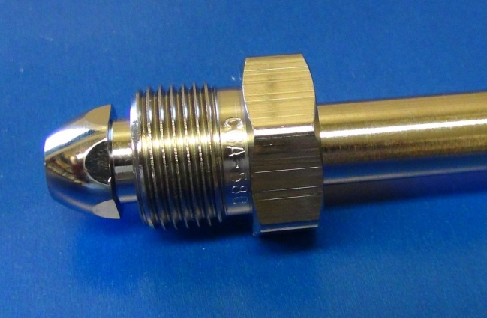  Fig 1: CGA 580 fitting | 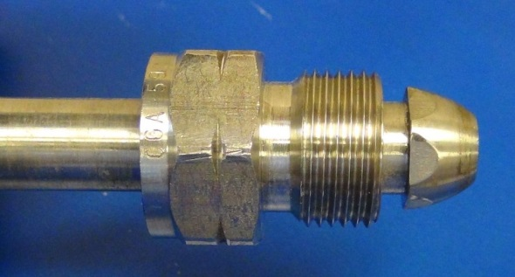  Fig 2: CGA 590 fitting. Note the notches cut into the nut, indicating a “left-hand” thread. This is commonly used for toxic gases.

Compressed Gas: A material that is contained within a storage vessel (typically a compressed-gas cylinder) above atmospheric pressure and that acts as a gas (state of matter) when released at normal temperature and pressure.
Gas Cabinet: A cabinet designed to hold compressed gas cylinders that is connected to an exhaust system (see photo). The exhaust system generally must produce an average velocity of 200 feet per minute at the access port or window with a minimum of 150 feet per minute at any point across these openings. Often these cabinets are also equipped with fire suppression sprinklers. Cabinets are equipped with self-closing doors and access openings. See figure 3 below.
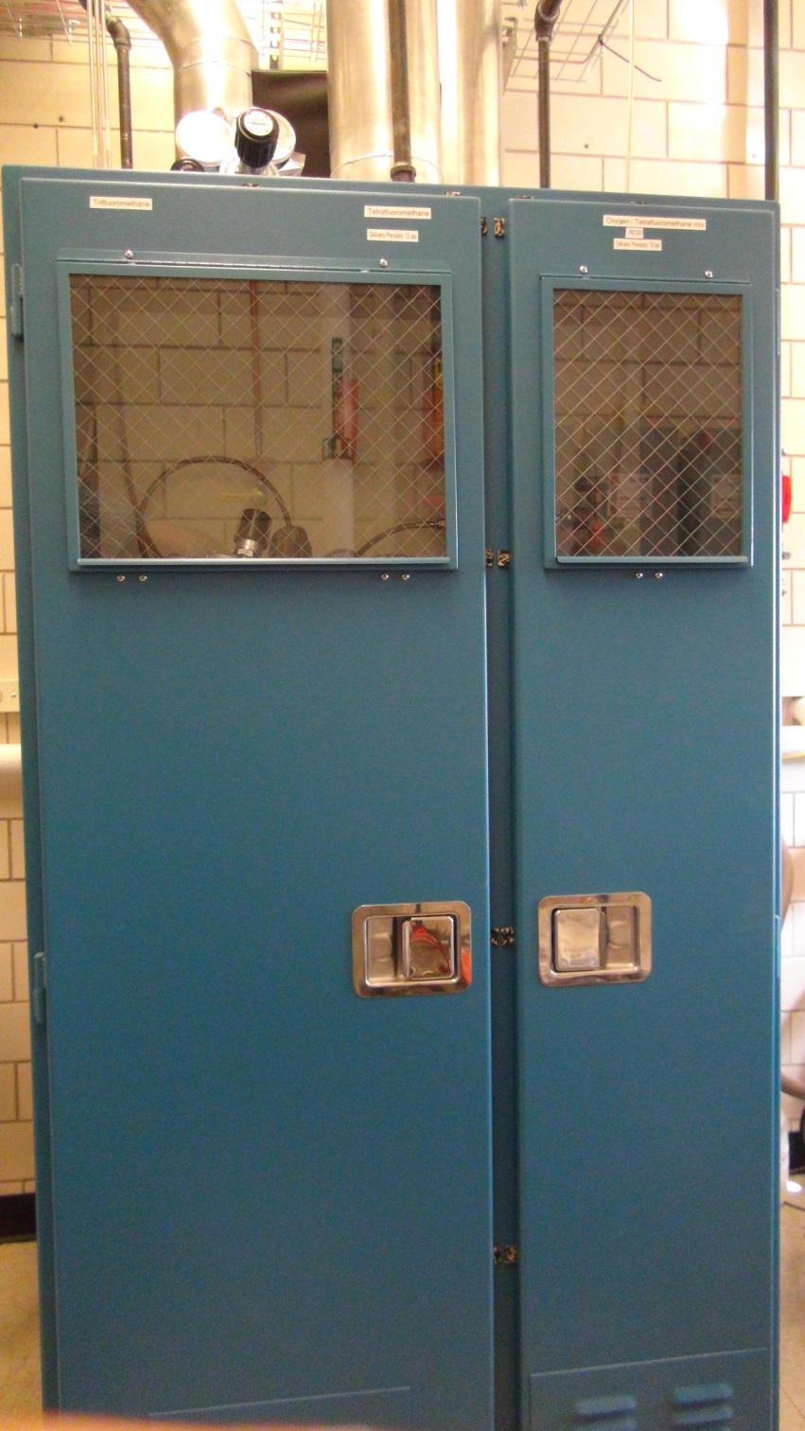
Fig 3: Gas cabinet designed to hold 3 gas cylinders.

GHS: The acronym for the Globally Harmonized System for labeling and classification of hazardous chemicals. The GHS was developed as an internationally agreed-upon system to replace the many classification- and labeling-systems so that consistent criteria are used globally to improve hazard communication. The GHS pictograms serves to provide information to the laboratory worker or researcher about hazards of chemicals under normal conditions of use. See figures 4 and 5 below.
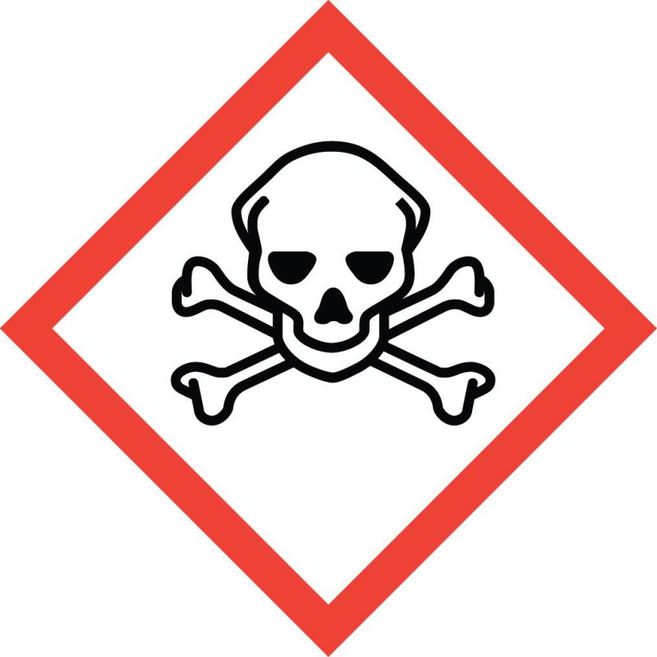 | 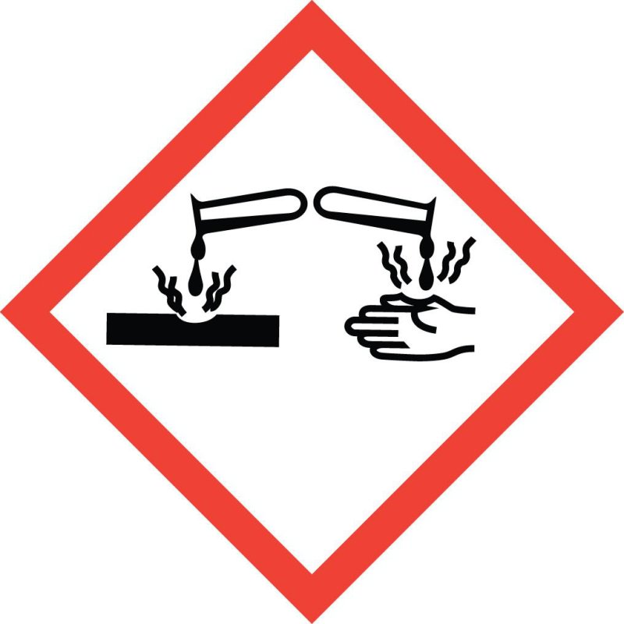 | 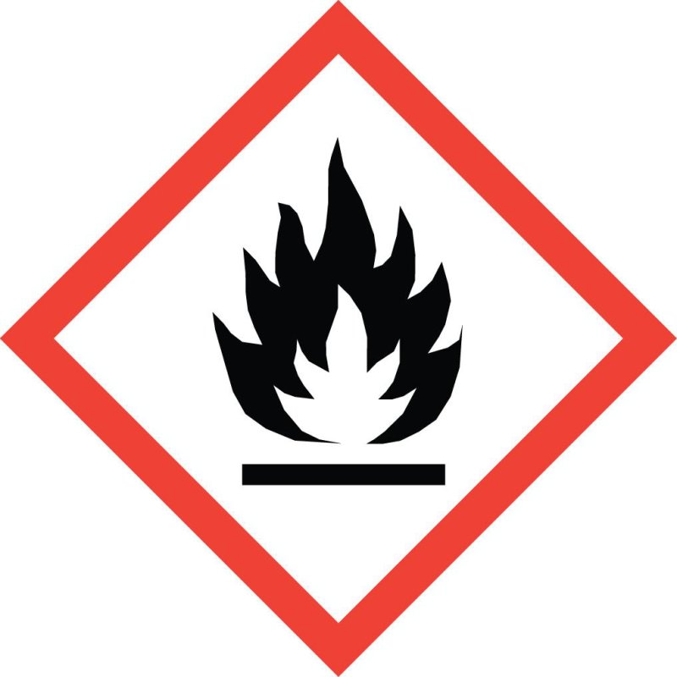
Fig 4: GHS symbols: Toxic, Corrosive, Flammable, and Gas Under Pressure (Compressed Gas)
IDLH: The acronym for a class of airborne substances or their concentrations defined by the National Institute for Occupational Safety and Health (NIOSH) as being Immediately Dangerous to Life and Health. Exposure to this class of contaminants is ‘likely to cause death or immediate or delayed permanent adverse health effects or prevent escape from such an environment.’ Besides indicating extreme danger, IDLH values help guide selection of breathing apparatus for persons working-in or exposed-to these environments (including oxygen deficiency), such as firefighters.
IFC: The acronym for the International Fire Code. The University of Illinois has adopted the (year) 2006 IFC. Among many other things, this code defines minimum performance requirements for gas cabinets.
LD₅₀ or LC₅₀: The acronym for an exposure code known as the Median Lethal Dose or Lethal Concentration. It describes the dose of a toxin, a pathogen, or of radiation that is fatal to 50% of exposed test animals of a certain type in controlled conditions, for a controlled duration. It can be expressed in numerous ways; for toxic gas exposure it is commonly expressed as ‘concentration per unit volume’ (ppm/m³ for example). This means that a lower value for LC₅₀ indicates a more toxic substance.
NFPA: The National Fire Protection Association is a US-based trade association that creates and maintains standards and codes for adoption by regulatory agencies. In a laboratory context, one of the most recognizable products of the organization is the NFPA diamond that shows numeric codes for hazard communication for emergency responders. See figure 5 below.
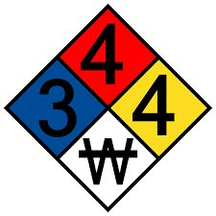
Fig 5: NFPA Diamond - blank and water incompatibility
OEL: The acronym for an exposure limitation known as the Occupational Exposure Limit. It describes the upper limit for allowable concentration of hazardous substances in air to which workers may be exposed.
OSHA: The acronym for the Occupational Safety and Health Administration. OSHA is an agency of the US Dept. of Labor that regulates workplace safety and health, including the research laboratory. This agency sets and enforces standards for worker safety, provides training, outreach, education, and assistance.
PEL: The acronym for an exposure limitation known as the Permissible Exposure Limit. It defines the maximum concentration of a substance that a person may be exposed to when averaged for an 8-hour time period. PELs have regulatory standing and are published in OSHA 29CFR 1910.1000.
Right-to-Know (RTK): A state-level law defining hazard communication. The State of Illinois requires employers to inform their employees about the harmful substances that they could be exposed to during the course of their work through training, availability of documentation (SDS, etc.), and signage, among others. The law is enforced by the state’s Department of Labor.
SCBA: The acronym for Self-Contained Breathing Apparatus, a positively pressurized full-face coverage breathing apparatus used to protect wearers from IDLH environments (Fig. 8). The main difference from a ‘respirator’ is that the device does not rely on consumable cartridges to filter ambient air. It uses pressurized cylinders to provide breathable air. The device’s positive pressure and demand pressure control prevent inward leakage from the ambient environment.
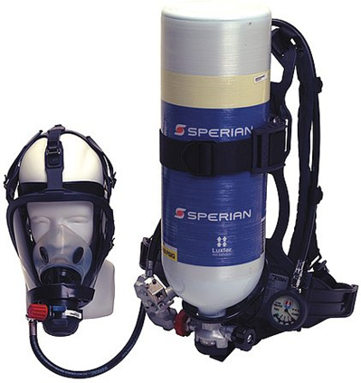 | 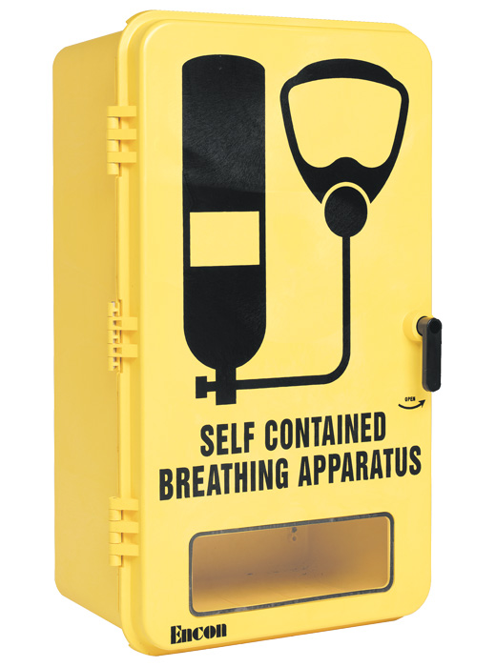
Fig 6: typical industrial SCBA and storage cabinet

Use of SCBAs falls under the purview of the respiratory protection program and will require training, fit-testing, medical evaluation, etc. This program is administered by Facilities & Services Division of Safety & Compliance. See: http://www.fs.illinois.edu/services/safety-and-compliance/employee-safety-health/respiratory-protection
STEL: The acronym for an exposure limitation known as the Short Term Exposure Limit. It defines a maximum exposure over a 15-minute time period.
TLV and TLV-TWA: The acronyms for exposure limits known as the Threshold Limit Value and additionally the Time Weighted Average. It describes a limit of exposure that is safe for workers to be exposed on a repeated (day-to-day) basis without harm. The TWA indicates a weighted average over an 8-hour-per-day and 40-hour work week. TLVs exist for chemical agents, noise, vibration, radiation, etc. They are expressed in parts-per-million (ppm) for gases. TLV is a term of the American Conference of Governmental Industrial Hygienists (ACGIH) which publishes these as recommendations. While they don’t have regulatory status, TLVs are issued annually by the ACGIH and are the most widely accepted exposure limits in the United States and many other countries.
Related terms:
TLV-STEL is the threshold limit value short term exposure limit; a spot exposure for a 15-minute duration that may not be repeated more than 4 times a day and may not occur less than 60 minutes between exposures.
TLV-C (Ceiling Limit) is an absolute exposure limit that may not be exceeded at any time.

Toxic Gas: A gas that causes significant acute health effects at low concentrations. Health effects may include pulmonary edema, neurotoxicity, severe skin or eye irritation, and/or other serious or fatal conditions. The criteria used to establish whether a gas is considered toxic (or highly toxic) include:
- a National Fire Protection Association (NFPA) health rating of 3 or 4
- a NFPA health rating of 2 if the gas exhibits poor physiological warning properties
- pyrophoric characteristics
- an extremely low Occupational Exposure Limit in the absence of an NFPA rating
Toxic Gas Monitor/Detector or Gas Monitoring/Detection System: A device used to detect leaks. The system uses consumable cartridges that are designed to detect a specific gas, basically by “sniffing” or sampling the air in a certain space or volume. Sampling lines are typically placed in the gas cabinet holding the gas cylinders, in the room housing the gas cabinets, and in the work area where gases are used, for example. Sampling is done for each individual gas which means that several monitors are commonly used. These detection systems also include devices to notify laboratory occupants of alarm conditions or servicing requirements (consumable expiration, for example). See figures 7 through 9 below.

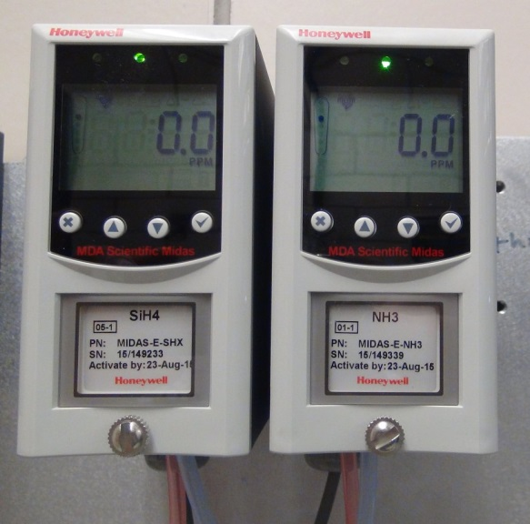  Fig 7: Gas monitors for Silane & Ammonia | 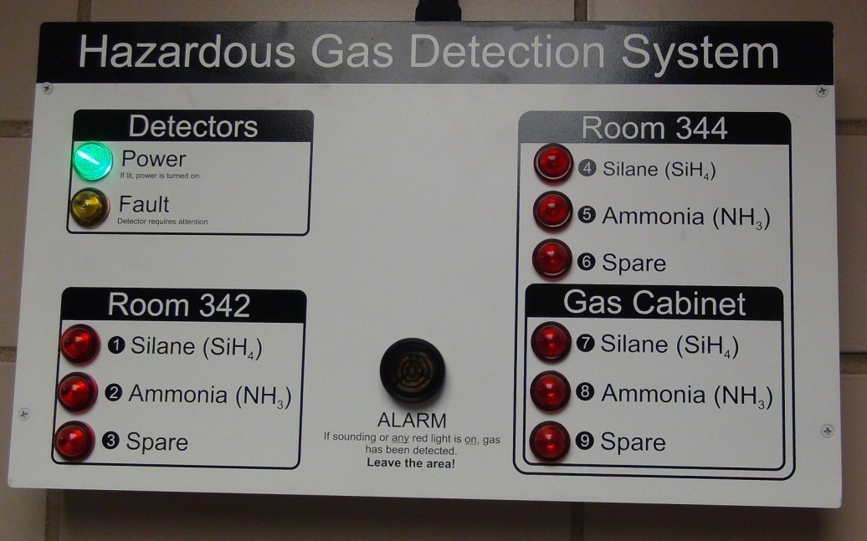  Fig 8: Gas Monitor Remote Display of the system’s status.

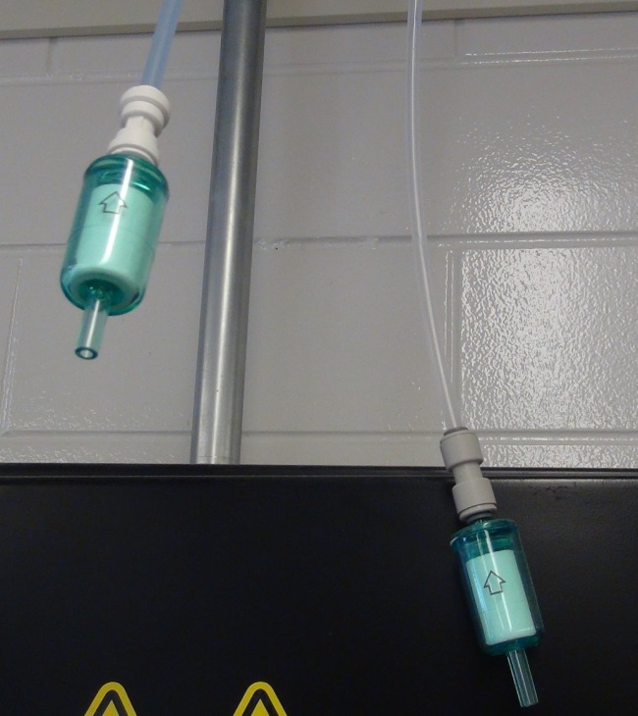 | 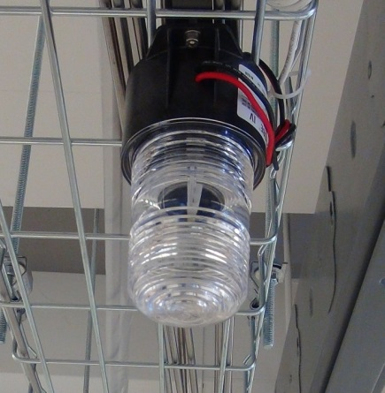
Fig 9: In- laboratory gas detector “sniffing” lines and emergency warning strobe light.

Tools and resources
Tools for Performing a Lab Risk Assessment
Hazard recognition and identification is the first step to creating a risk assessment for your laboratory procedure. The following links provide guidance in identifying hazards and assessing the risks from the hazards.
American Chemical Society: Hazard Assessment in Research Laboratories
Division of Research Safety: Standard Operating Procedures

Tools for selection of hazard controls
Once the hazards have been identified, control measures aim to eliminate or mitigate (lessen) the risk from each hazard. Consult: American Chemical Society: Control Measures
Chemical fume hoods are an important engineering control as they provide protection from vapors, splashes and impacts from chemicals and their reactions. Consult: Division of Research Safety: Fume Hoods
PPE should be considered as the the last line of defense against exposure to hazardous materials. If used, they should be selected correctly to protect against the hazardous material and must fit the wearer. Each person using PPE must understand when PPE is needed, what PPE is needed, how to properly wear, adjust, and remove PPE, as well as how to clean or maintain or dispose of PPE. Personnel must understand the limitations of PPE. Consult: Division of Research Safety: Personal Protective Equipment

Change management
The SOP needs to be reviewed on an annual basis and whenever events or conditions arise that trigger a review, such as:
- An incident or significant near miss or close call.
- Modifications to equipment other than replacement in kind.
- Use of a commercial product for a purpose for which it was not designed.
- Increased risk beyond what is covered in the SOP.
- New experiment, equipment, or control software.
- A change/improvement in an SOP or other program document is made.
- New materials are introduced to an experiment that were not accounted for in the SOP.
- Changes in essential personnel.
It also helps to maintain a change management document that lists sections or items in the SOP that need to be checked in every review, such as: web links, names of resource persons, or other information that might become outdated.

Reference material
Prudent Practices in the Laboratory. Handling and Management of Chemical Hazards. NRC (National Research Council). National Academy Press: Washington, DC, 2011.
Identifying and Evaluating Hazards in Research Laboratories. ACS (American Chemical Society) 2015.

Record of changes made to this SOP
Describe the changes made to this document since its creation. Identify the personnel who made the edits or revisions and when the change was made.
Date of change | Changed by | Description of change

Standard Operating Procedure for SOP_Title

Training record
Training Date | Name of Trainer | UIN of Trainer | Initials of Trainer | Name of Trainee | UIN of Trainee

